Homework 2
Due date: Friday, October 2 – submit by 11:00 PM
1. Purpose: reinforce your understanding of the selection problem.
(6 points) Solve Problem 9.3-1 on page 192 of our textbook.
- When divided into groups of 7, the step 3 will take T(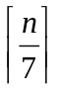) time. For step 5, the number of elements greater than the median of medians x will be at least
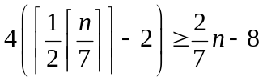
Thus, step 5 takes at most T(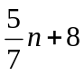).
We could obtain the recurrence:
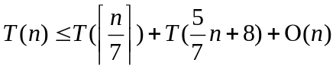
Assume that 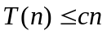 for some suitably large constant c,
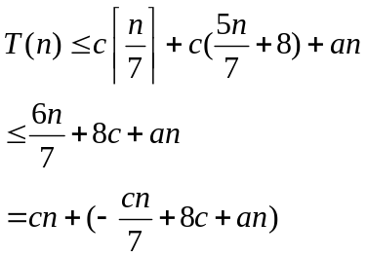
We need to prove 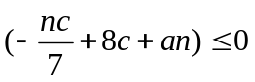 for some large constant c.
The inequality could be transformed as 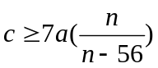
When 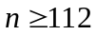, we have 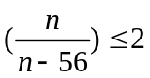, and so choosing 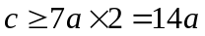 and , we could satisfy . Therefore, when dividing into groups of 7, the running time is still linear.

- When divided into groups of 3, we could obtain the recurrence:
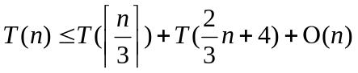
We assume that 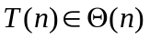, so we have 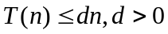
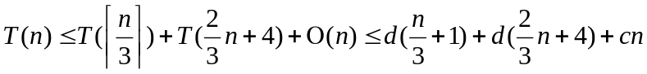
= 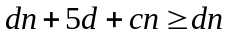
This is contradict with the assumption that . Thus, when divided into groups of 3, SELECT does not run in linear time.

2. Purpose: reinforce your understanding of counting sort.
(3 points) You are given an array of numbers A with n elements , your task is to find the largest gap, that is, two numbers A[i] and A[j] such that A[i] < A[j] and there is no A[k] in the array such that A[i] < A[k] < A[ j], and so that A[ j] – A[i] is maximal. You have to do it in time O(n).
Hint: find minimum and maximum numbers, say a and b, respectively. Define g = (b - a) / (n - 1)). Clearly, the maximum gap has A[j] - A[i] ≥ g. Split the numbers in the array into intervals of the form [a + kg, a + (k + 1)g]. The maximum gap cannot be within one of these intervals. This method is inspired by counting sort because you map A[m] into the interval number floor((A[m] – a) / g), and we can sort them according to these interval numbers.
My algorithm of FindMaxGap will find out the min and max value of the whole array, which will takes 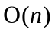 time. And then calculate the average interval 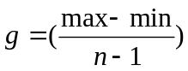, which takes 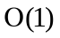 time. The following step would be to split the elements in the array into different intervals [a + kg, a + (k + 1)g], k = 0…n-1. Given A[i], we could compute 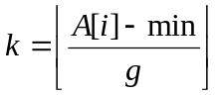 and put A[i] into kth interval, which also takes time. Obviously, the maximum gap is not less than the average gap. Thus, the pair of elements having the maximum gap could not be found inside the same interval. With this property, we could just compare the max element in the interval whose value is smaller with the min element in the interval whose value is larger to find out the maximum gap. The algorithm to find out the max and min in each interval runs in linear time. As the total number of elements in all the intervals is n, finding out min and max in every interval takes time. Clearly, comparing the max with the min in the following intervals still takes time. Therefore, the total time for the algorithm is :
Finding out min and max of the array:
Compute the average interval: O(1)
Split the element into intervals:
Find out min and max in each interval:
Comparing min and max in the following intervals:
+O(1)+ ++ = . The algorithm will run in time.

FindMaxAndMin(A,max,min)
i = 1;
min = A[i]
max = A[i]
if(n mod 2 == 1) // n is odd
i = i + 1;
while i <= n
smaller = 0;
larger = 0;
if A[i] > A[i + 1]
smaller = i + 1;
larger = i
else
smaller = i;
larger = i + 1
if A[smaller] < min
min = A[smaller]
if A[larger] > max
max = A[larger]
i = i + 2;

FindMaxGap(A)
n = A.length
min = 0
max = 0
FindMaxAndMin(A, max, min)
g = (max - min) / (n - 1)
B = List [] // an array of list
for i = 0 to n – 1
k = (A[i] - min)/g
B[k].add(A[i])
C = Array[][] // 2-dimension array,
for i = 0 to n – 1
FindMaxAndMin (B[i], C[i][0], C[i][1]) // C[i][0] is max, C[i][1] is min,
// if no element in this interval, assign null to C[i][0], C[i][1]
maxgap = 0
start = null
end = null
for i = 0 to n – 2
if( start == null && C[i][0] != null){
start = i
}
if(C[i+1][1] != null){ // check if the interval has element
end = i + 1
gap = C[start][0] – C[end][1]
if (gap > maxgap){
maxgap = gap
}
start = end // update the start index
}
else
{
continue;
}
return maxgap

3. Purpose: reinforce understanding of decision trees.
(4 points) Solve Problem 8-1, parts a–c and e on page 178.
- A correct sorting algorithm must be able to sort every input of A and its output must be one of the permutations of A, which means these n! leaves must be reachable by given an input. As every permutation of A’s input is equally likely, we have 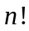 permutations and each permutation’s probability is 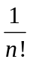. The leaves of 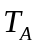 is the permutations of A. Thus, there are exactly leaves and each of them is labeled for its probability.
- In , there are k leaves. Thus, when we increase the level of LT and RT, k leaves’ path to root will all increase by one, which results in k.
Therefore, we have 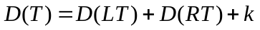
- As proved in b), we have .
For 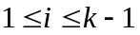, we could find a RT which has i leaves and D(RT) = d(i). We could also find a LT which has k – i leaves and D(LT)=d(k-i). By building a T using these LT and RT, we have
As d(k) is the minimum of D(T), we have 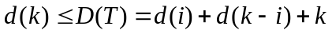
For , we could find a T with k leaves and D(T)=d(k). By using the formula in b), we have
where LT has i leaves and RT has k-i leaves.
By definition, 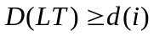 and 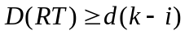, so we have
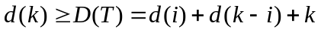
Therefore, 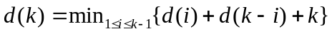as 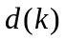
- Not required
- From d), we could know that 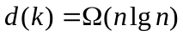, so we have
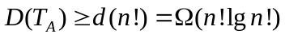
As D(T_{A}) is the sum of paths for all inputs permutation and there are leaves, each of which has 1/n! probability, the expected to sort n elements is:
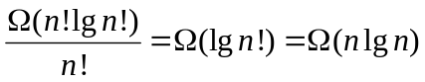
4. Purpose: Apply recursion to solve a problem, practice formulating and analyzing algorithms.
In the US, coins are minted with denominations of 50, 25, 10, 5, and 1 cent. An algorithm for making change using the smallest possible number of coins repeatedly returns the biggest coin smaller than the amount to be changed until it is zero. For example, 17 cents will result in the series 10 cents, 5 cents, 1 cent, and 1 cent.
a) (2 points) Write a recursive algorithm for changing n cents.
d [5] = {50,25,10,5,1}
Change(cents, results[], i)
if (i < d.length ){
num = ceil(cents / d[i])
rem = mod(cents, d[i])
results[i] = num
i = i + 1;
Change(rem,results,i)
}

b) (2 points) Analyze its time complexity.

As the length of d is always 5, there will be 5 recursive calls of Change for any number of cents. Thus the complexity is O(1).
c) (2 points) Write an O(1) (non-recursive!) algorithm to compute the number of returned coins.
d [5] = {50,25,10,5,1}
Change(cents, results[])
while cents > 0
num = ceil(cents / d[i])
cents = mod(cents, d[i])
results[i] = num
i = i + 1

d) (1 point) Show that the above greedy algorithm does not always give the minimum number of coins in a country whose denominations are 1, 6, and 10 cents.
When changing for 32 cents, the above greedy algorithm will give 3 dimes and 2 cents. However, the minimum number of coins should 2 dimes and 2 6 cents, the total of which is only 4 but not 5.
e) (2 points) What is the average number of coins that your algorithm from part (a) returns if you have to change 1,2,…,100 cents, and every amount appears with the same probability?
The table below shows the possible combinations of coins for cents which is within the range from 1 to 100:
Cents | 50 | 25 | 10 | 5 | 1
Value | 0 | 0 | 0 | 0 | 0
Value | 1 | 1 | 1 | 1 | 1
Value | 2 |  | 2 |  | 2
Value |  |  |  |  | 3
Value |  |  |  |  | 4
We could calculate the number of coins will be used for a given number between 1 to 100 based on this table:
If we choose one 50 cent coin, then we have 2 values for 25 cents, 0 or 1, 2 values for 10 cents, 2 values for 5 cents and 5 values for 1 cent. The value of two 10 cents is special, because when there are two 10 cents, there could not be any 5 cents. Therefore, we have:
One 50 cents: 2 * 2 * 2 * 5 + 2*1*1*5 = 50
Two 50 cents: 2 (only 100 could have two 50 cents)
The analysis is similar for the 25:
One 25 cents: 2*2*2*5 + 2*1*1*5 = 50
For 10 cents, when there are two 10 cents, the number of 5 cents could only be 0:
One 5 cents: 2*2*2*5 = 40
One 10 cents: 2*2*2*5 = 40
Two 10 cents: 2*(2*2*1*5) = 40, the first 2 means two 10 cents.
For 1 cents, the calculation is similar:
One cents: 2*2*2*2 + 2*2 = 20
Two cents: 2*(2*2*2*2 + 2*2) = 40
Three cents: 3*(2*2*2*2 + 2*2) = 60
Four cents: 4*(2*2*2*2 + 2*2) = 80
The sum of all these gives:
50 + 2 + 50 + 40 + 40 + 40 + 20 +40 + 60 + 80 = 422
As the every amount appears with the same probability, the average number of coins is 422 / 100 = 4.22

